**SUBMITTED BY: TEAM:** **B2**



**A**

**R**

**E**

**V**

**E**

**R**

**S**

**E**

**E**

**N**

**G**

**I**

**N**

**E**

**E**

**R**

**I**

**N**

**G**

**R**

**E**

**P**

**O**

**R**

**T**

**O**

**N**

**H**

**Y**

**D**

**B**

**A**

**L**

**E**

**M**

**A**

**C**

**H**

**I**

**N**



|  |  |  |  |  |
| --- | --- | --- | --- | --- |
| USN |  | NAME |  | ROLL NUMBER |
| 01FE20BME133 |  | ROHIT VERNEKAR |  | 251 |
| 01FE20BME059 |  | BANGARAPPA .B |  | 242 |
| 01FE20BME076 |  | NANDISH APPOJI |  | 245 |
| 01FE20BME068 |  | NANDAN JADHAV |  | 243 |
| 01FE20BME |  | SHASHANK AYALI |  | 209 |
|  |  |  |  |  |

**Introduction**: A **miter saw** or **MITRE saw** is a saw used 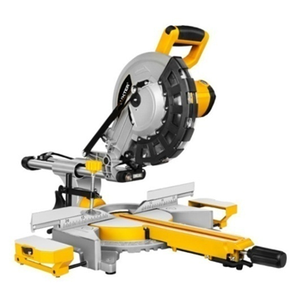to make accurate crosscuts and miters in a work piece by positioning a mounted blade onto a board. A miter saw in its earliest form was composed of a back saw in a miter box, but in modern implementation consists of a powered circular saw that can be positioned at a variety of angles and lowered onto a board positioned against a backstop

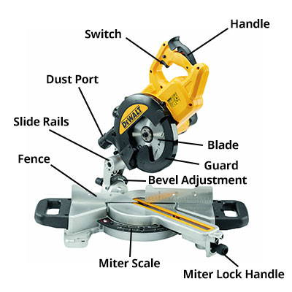**Parts of Mitre saw**

1. Motor
2. Handle
3. Blade
4. Guard
5. Base
6. Motor holder

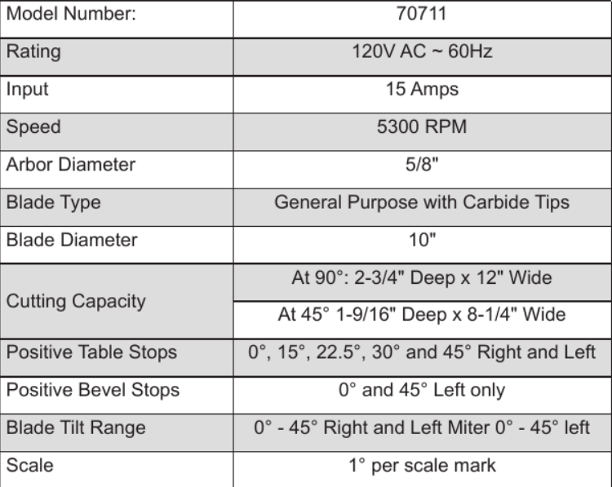 Specifications of miter saw

**2-D Drawing of Mitre saw**

***Base for mitre saw***

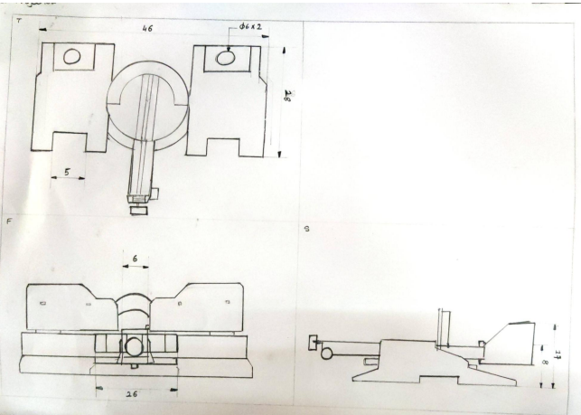

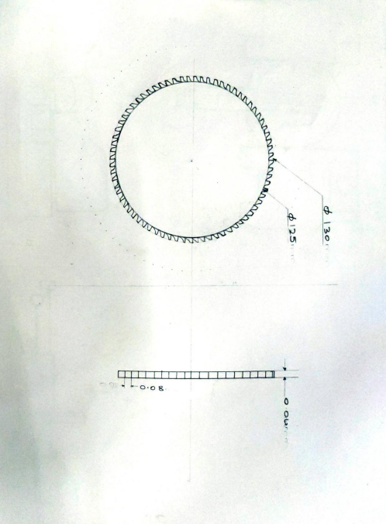***Blade of mitre saw***

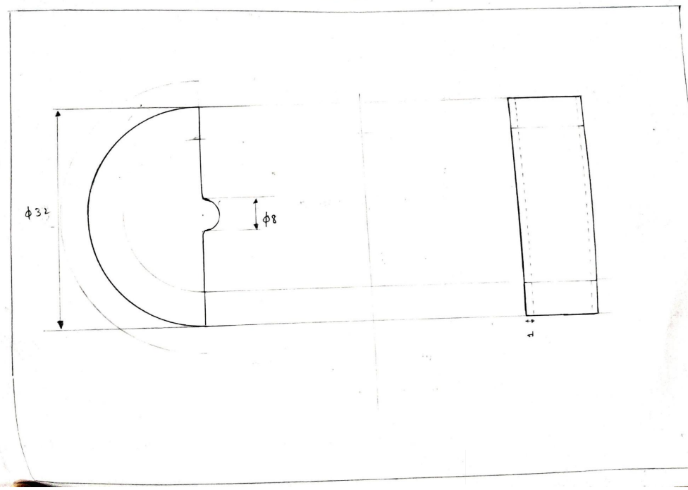***Blade of mitre saw***

*Motor for mitre saw*

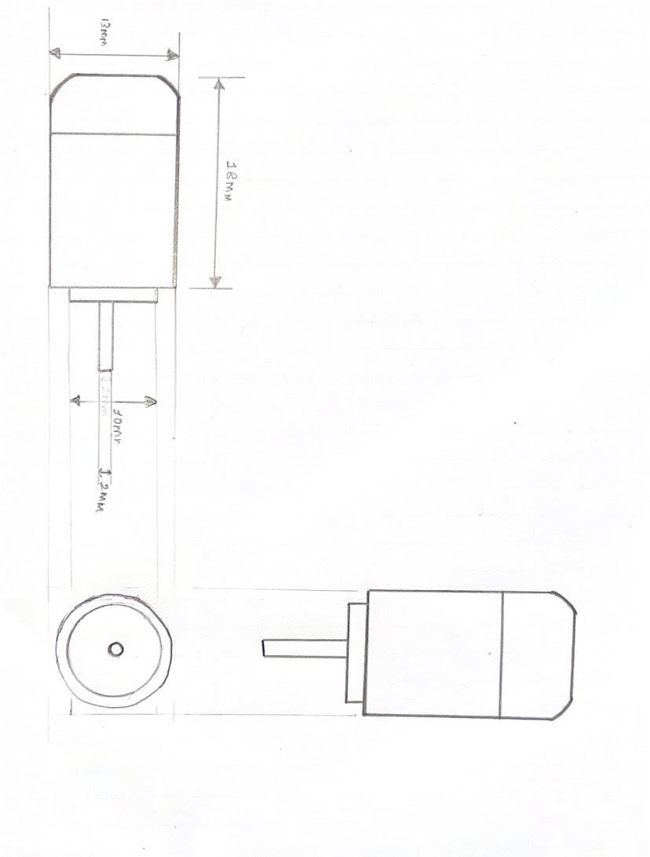

**3-D Parts of Mitre saw**

***Blade of mitre saw***

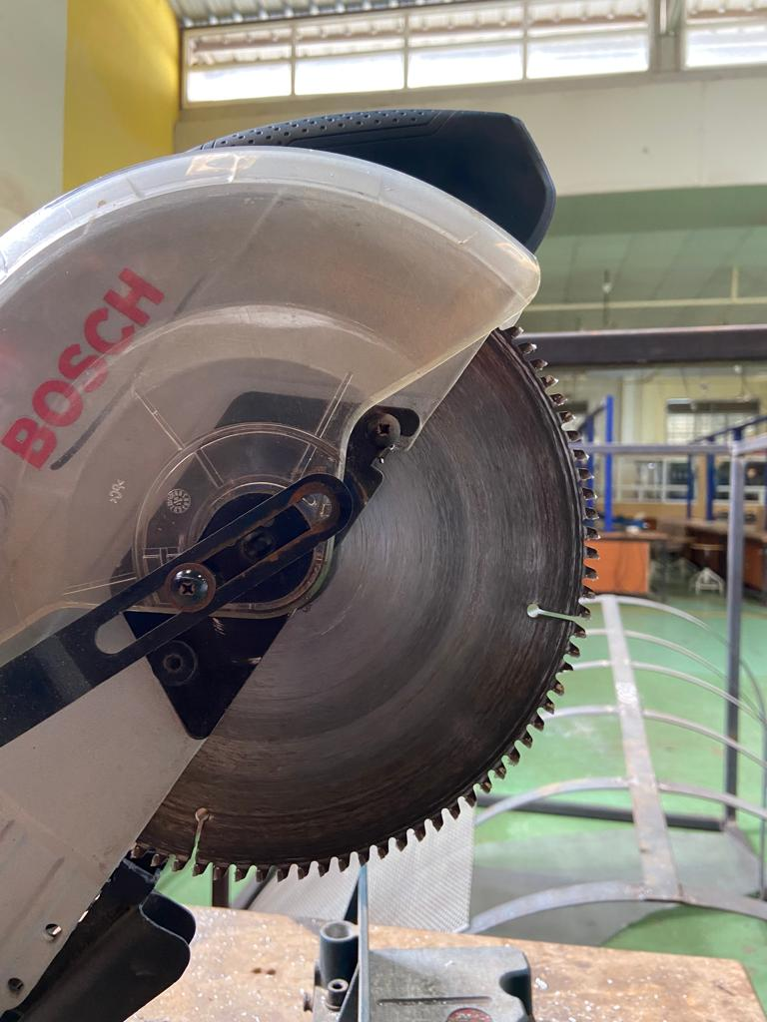

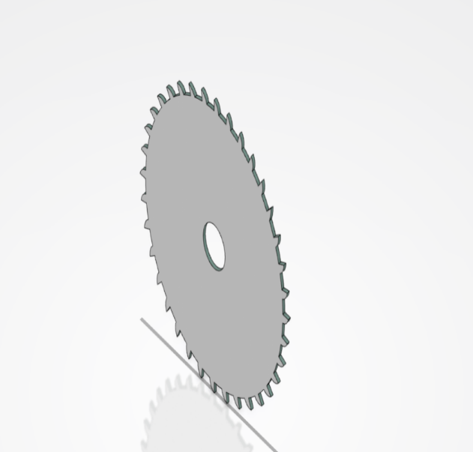

**Blade guard**

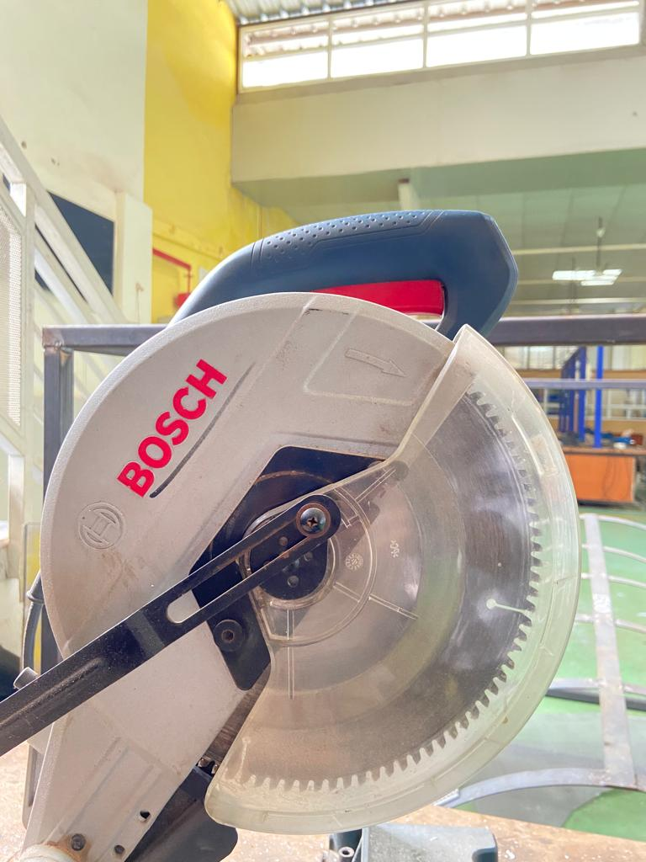

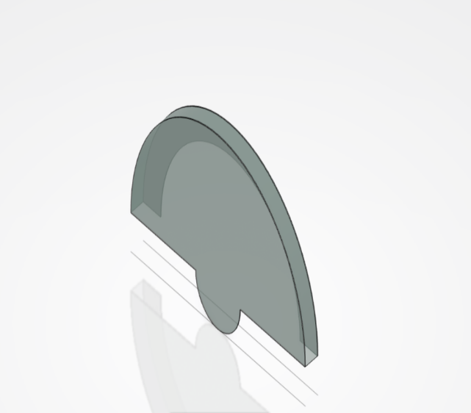

**Motor with handle**

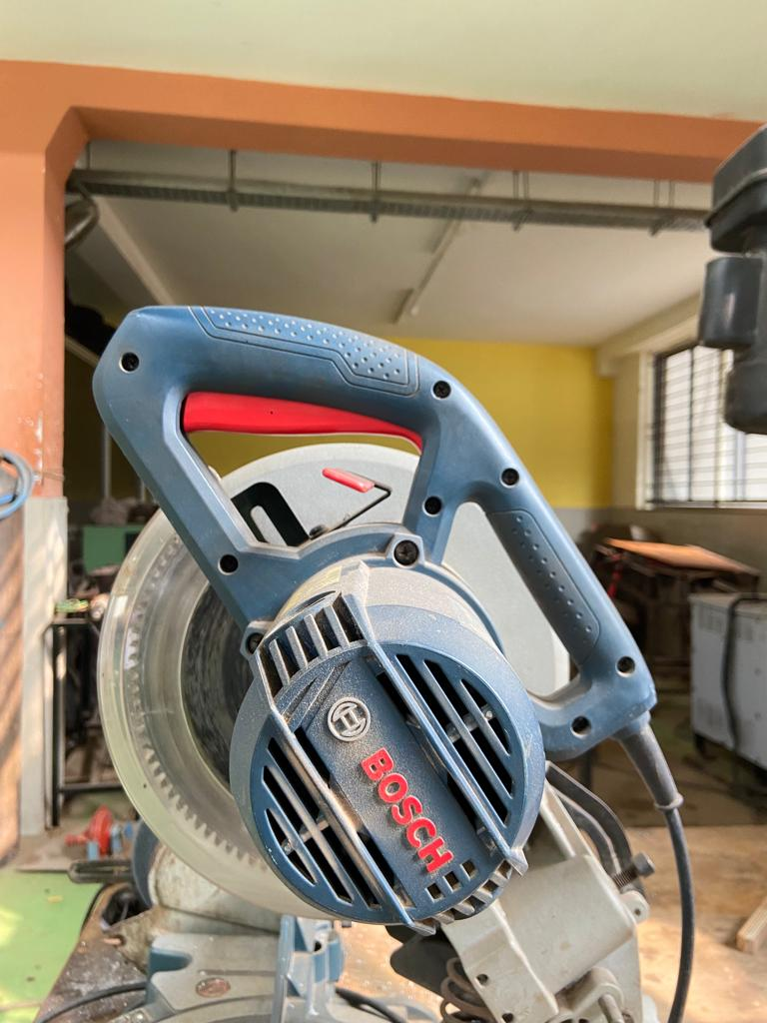

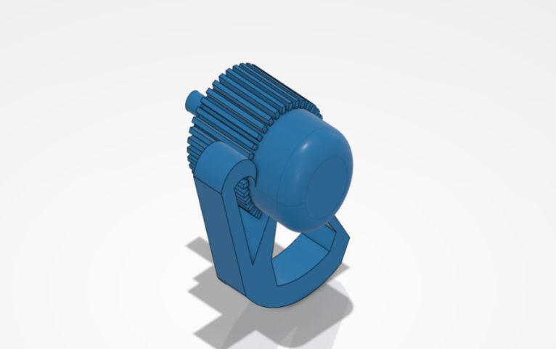

**Motor holder**

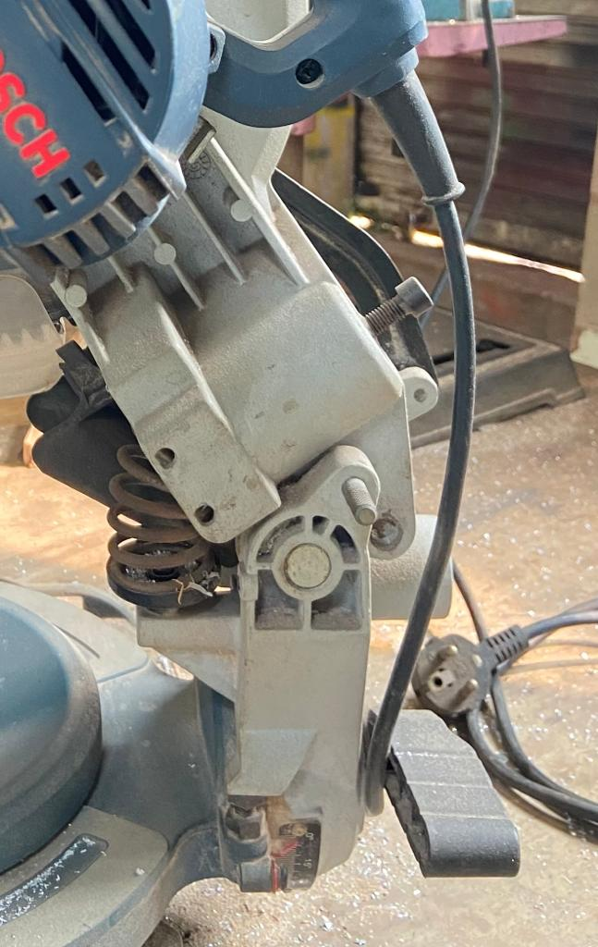



**Base of mitre saw**

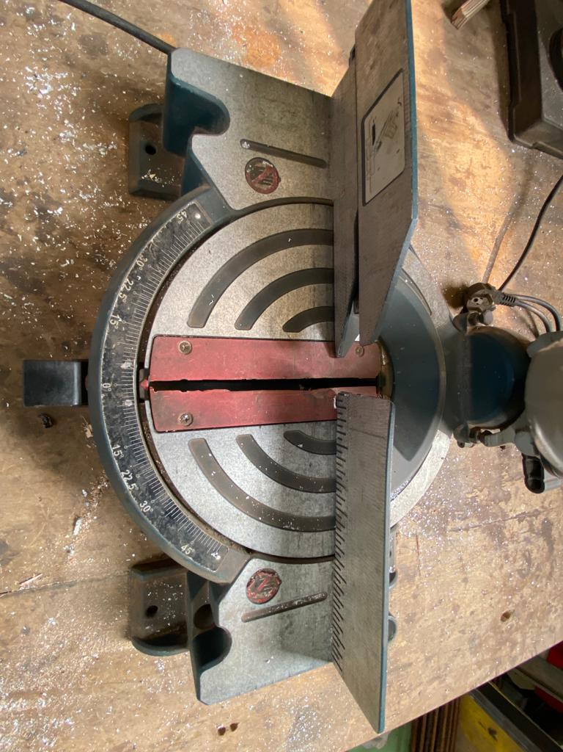

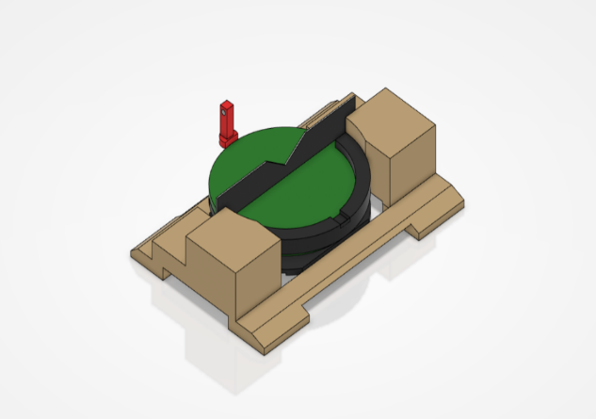

***Drafting of mitre saw***

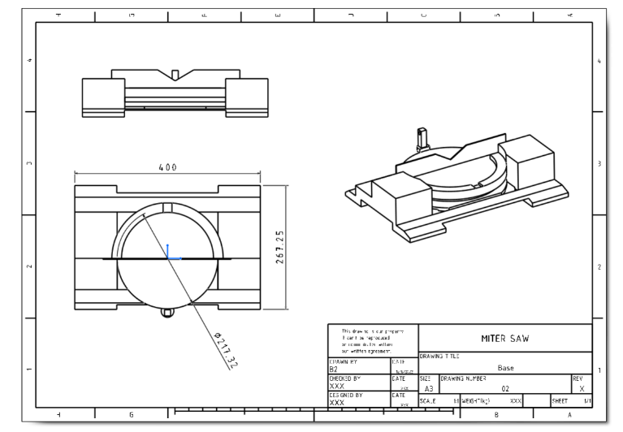

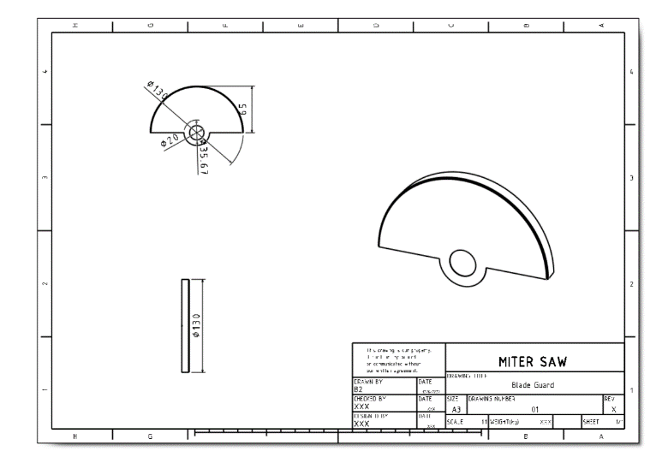

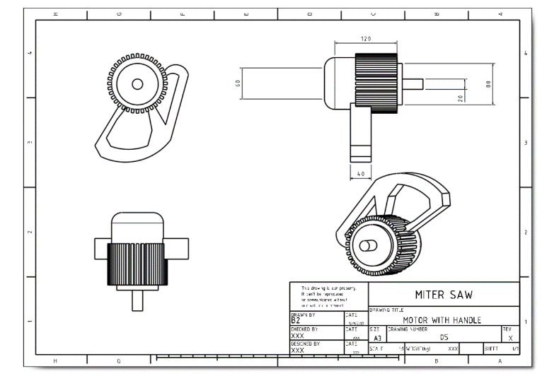

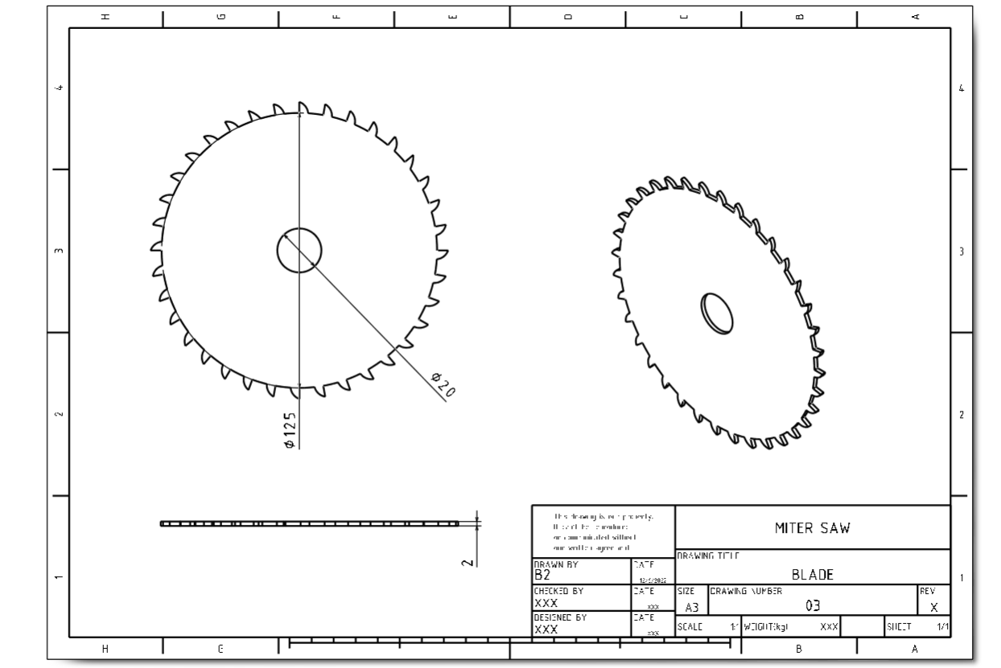

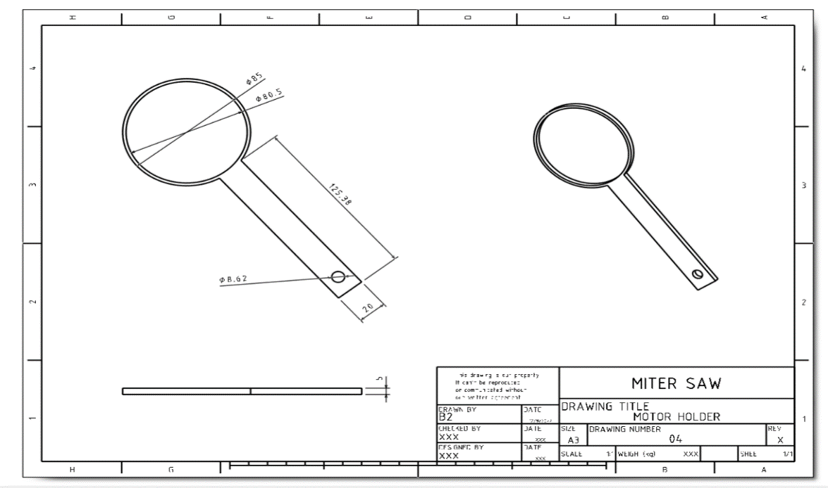

Ballooning of miter saw

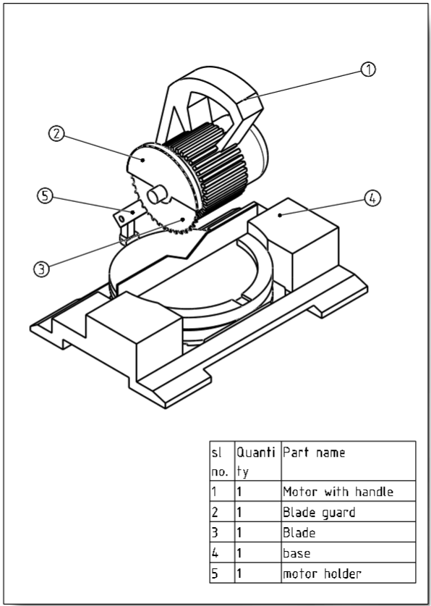

Rendering

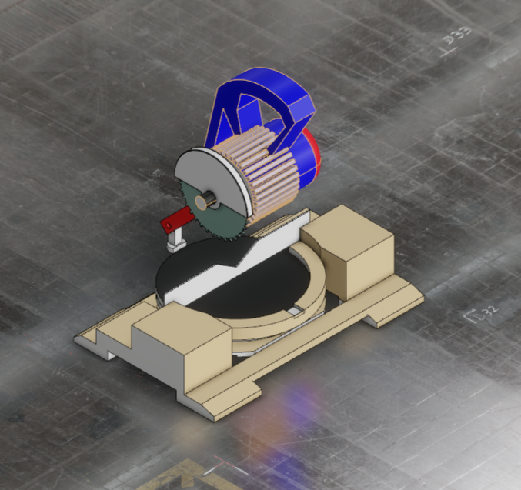

3-D Views of miter saw

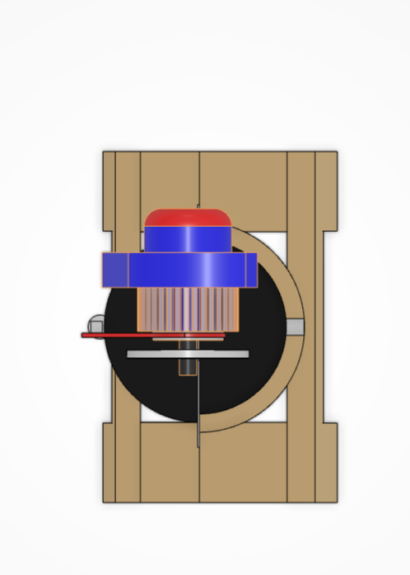 Top view

Front view

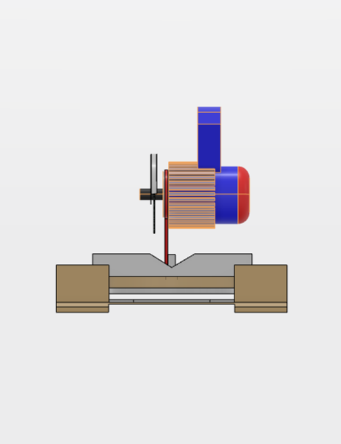

Side view

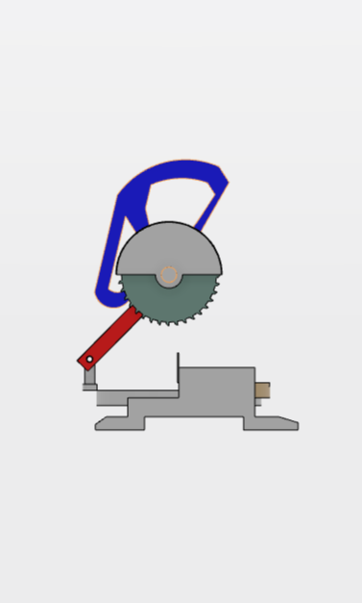

Isometric view

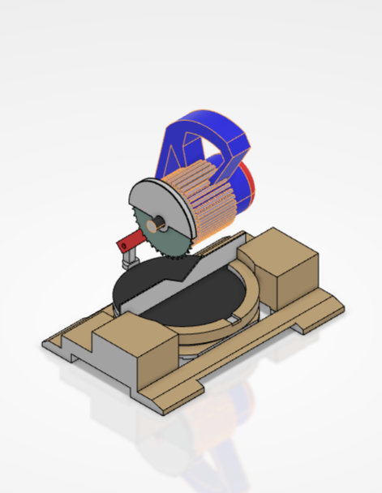

Exploded view

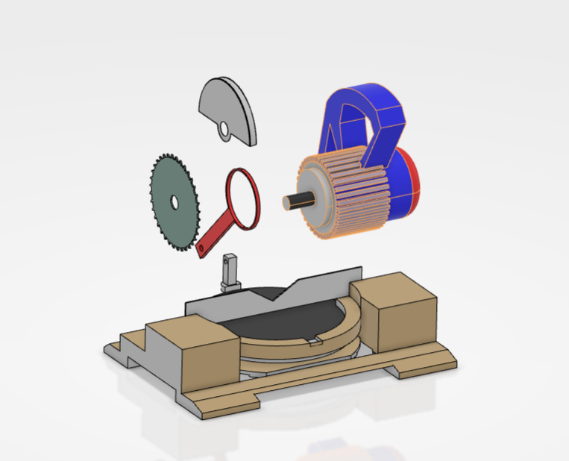

Conclusion

Reverse engineering can help you see inside a product and find the hidden strengths and weaknesses. This lets you judge a product more deeply; and reach beyond the typical criteria of functionality, cost, vendor stability, and the attractiveness of the user interface. None of the typical criteria can directly assess the intrinsic quality of an application, but you can assess it with reverse engineering. When you consider the high cost of many software deployments and the low cost of reverse engineering (a few weeks of effort), the benefit that you can obtain with reverse engineering is truly a bargain. Not only can reverse engineering improve a purchase decision, but it also benefits the software community as a whole. We all know that software costs too much, is of uneven quality, and takes too long to deliver. This is the motivation for software engineering for taking a systematic and thoughtful approach to building software. Yet we see that software engineering alone is insufficient. Even with software engineering, we still have too much flawed software and the resulting software crisis.